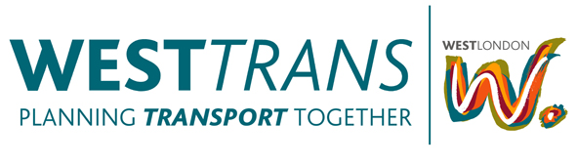
Date: Thursday 16th May 2013, 3.45pm-5pm
Location: Ealing Town Hall, Nelson Room

Chair: Tim Forrester, WestTrans

Agenda
- Apologies
- Notes of Last Meeting/Matters Arising
- WestTrans Work Programme update:
  - WL Cycling Study project update
  - WL Freight
  - WestTrans funding allocations for 2013/14 (inc. MO post)
- Borough round-ups:
  - Please come prepared to provide an update on current activity
- Any Other Business
  - European Cycle Challenge
  - WestTrans DC TP Training 4th & 5th June 2013
- Date of Next Meetings

Scheduled to take place on:
- Thursday 25th July 2013 @ 2.00pm – Ealing Town Hall, Nelson Room
- Thursday 20th Sept 2013 @ 2.00pm – Ealing Town Hall, Nelson Room
- Thursday 29th Nov 2013 @ 2.00pm – Ealing Town Hall, Nelson Room
- Thursday 23rd Jan 2014 @ 2.00pm – Ealing Town Hall, Nelson Room
- Thursday 20th March 2014 @ 2.00pm – Ealing Town Hall, Nelson Room

